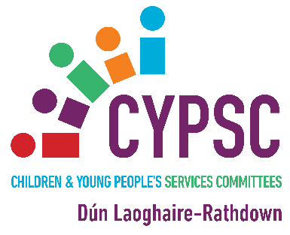



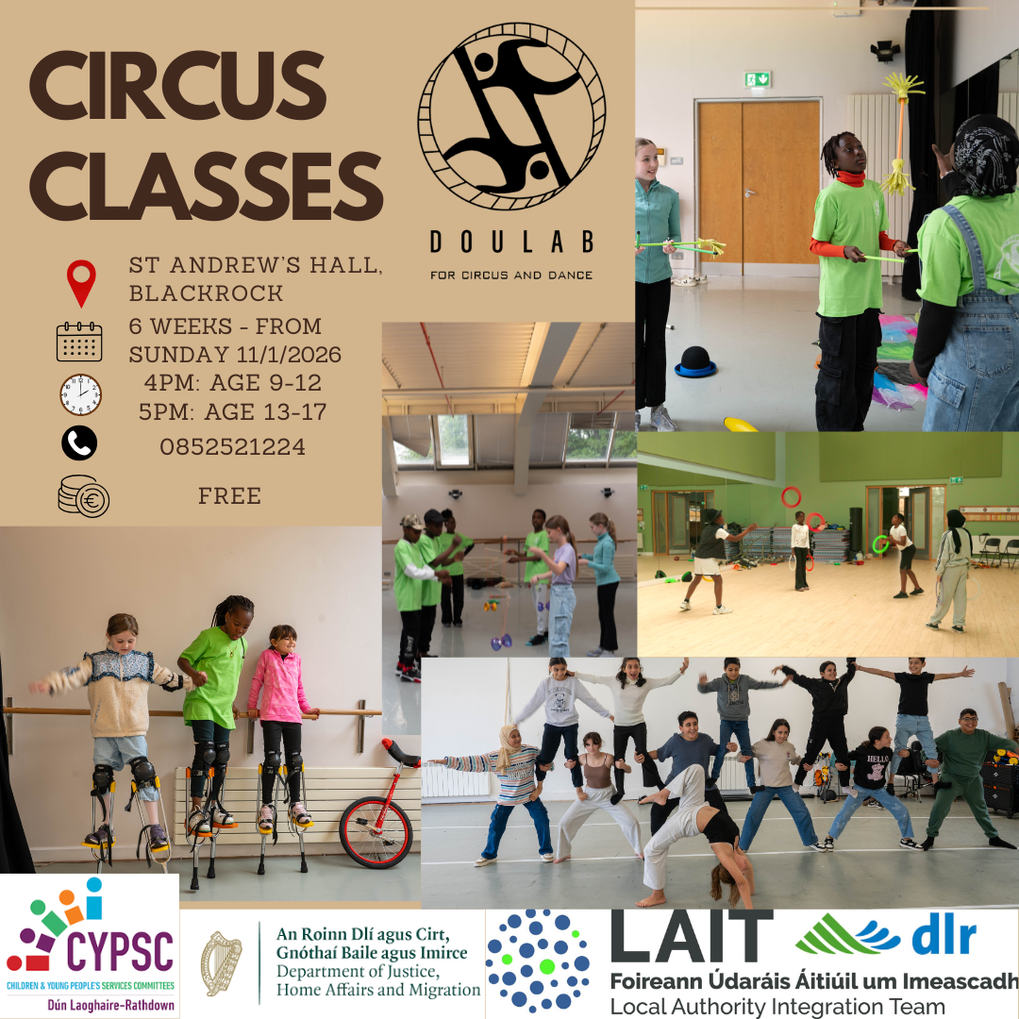

  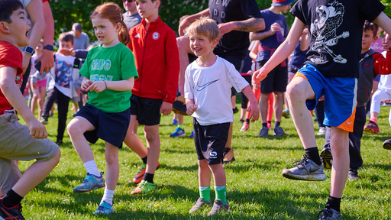 | Cabinteely Junior Parkrun  What is Cabinteely junior parkrun?  A free, fun, and friendly weekly 2k event for juniors (4 to 14 year olds). Nearby Saturday parkrun events can be found here.  When is it?  It is held every Sunday at 9:30am.  Where is it?  The event takes place at Cabinteely Park, Park Drive, Cabinteely, Dublin 18. See Course page for more details.  What does it cost to join in?  Nothing - it's free! but please register before you first come along. Only ever register with parkrun once and don't forget to bring a scannable copy of your barcode (request a reminder). If you forget it, you won't get a time.  How fast do I have to be?  The aim is to have fun. Please come along and join in whatever your pace!  Find more info HERE on Cabinteely Junior Parkruns and others nearby.
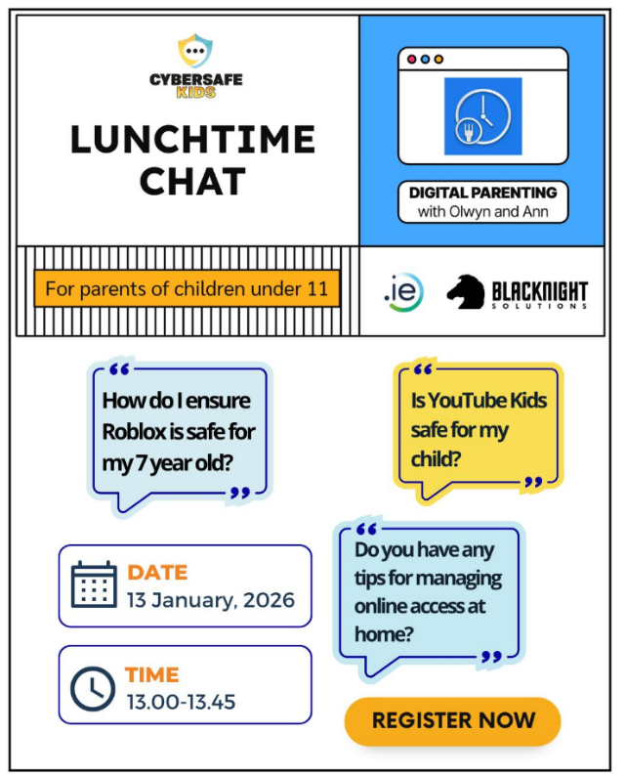 | CyberSafeKids Lunchtime Chat  Join two of our most experienced CyberSafeKids trainers, Olwyn Beresford and Ann Harte, for a relaxed lunchtime conversation (via Zoom) where we can chat all about managing your child​'s ​d​igital life.  ​Grab a sandwich and tune in for 45 minutes of practical tips and strategies to help your school-aged children (up to 11 years) navigate the online world safely.  Whether you want to just sit back and listen or you have a question or concern, this is your opportunity to join the conversation on digital parenting.  🗓️​ Tuesday, ​13th January 202​6​: Parents of primary school-aged children up to 11 years  ⏰ 13:00–13:45  You can register HERE
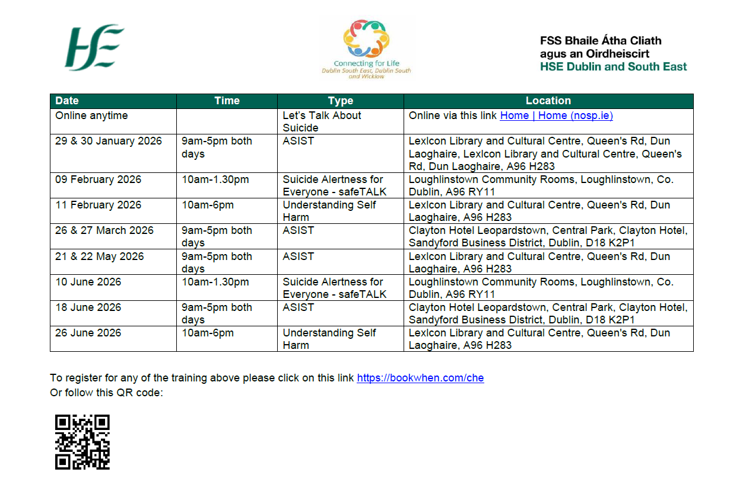
BOOK HERE and see flyer attached

