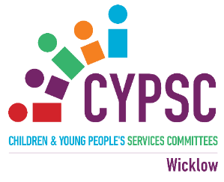

Welcome to the New Year Wicklow CYPSC News Update:
9th January 2026

Page 2: Prevention of Drugs and Alcohol Needs Assessment Survey extended to 12th January
Page 3: Understanding how to bring more emotional happiness into our lives 14th January
Page 4: Aras Addiction Service - Drop In Clinic in Dunlavin commencing 15th January
Page 5: Recruitment for the Guardian ad Litem National Service 15th January
Page 6: Anam Cara – Online Information Bereavement Evening – 22nd January
Page 7: Arches Recovery College – January to March 2026 Events
Page 8 & 9: Irish Hospice Foundation – National Grief Awareness Week 26th Jan to 1st Feb
Page 10: National Young Carers Conference 7th March
REMINDERS
Page 11: Employment Opportunity – U18 Project Worker
Page 12: Free Suicide Awareness Training in 2026 and HUGG Volunteer Information Sessions and Request
Page 13: Tusla Fostering looking for events in 2026
Page 14: Irish Hospice Foundation - Bereavement and Loss Workshops 2026
Page 15: Creative Ireland Call for Applications 2026 (Check out the dates for Information Sessions – 1st one 15th December – booking required)
Page 16: Parents Plus Facilitator Training 2026

Fionnuala Curry
Coordinator, Co. Wicklow CYPSC
Fionnuala.curry@tusla.ie or call 087 6043511

Dear Colleague,

Many thanks to those of you who have already completed the National Stakeholder Survey in relation to the Prevention of Drugs and Alcohol Needs Assessment that we recently circulated.

If you have not yet had an opportunity to complete the survey, we would be very grateful for your input.

Please note that the deadline for completion has now been extended to 12th January 2026.

The survey is intended to capture perspectives from a wide range of stakeholders and will help inform a broader programme of work contributing to the national needs assessment and strengthening prevention across the life course. It takes approximately 10–12 minutes to complete.

We would also appreciate it if you could share the survey with relevant colleagues or networks, where appropriate.

If you have any questions or would like to discuss any aspect of this work further, please feel free to contact me. Thank you again for your time and continued engagement.

Please follow the link below to complete the survey:

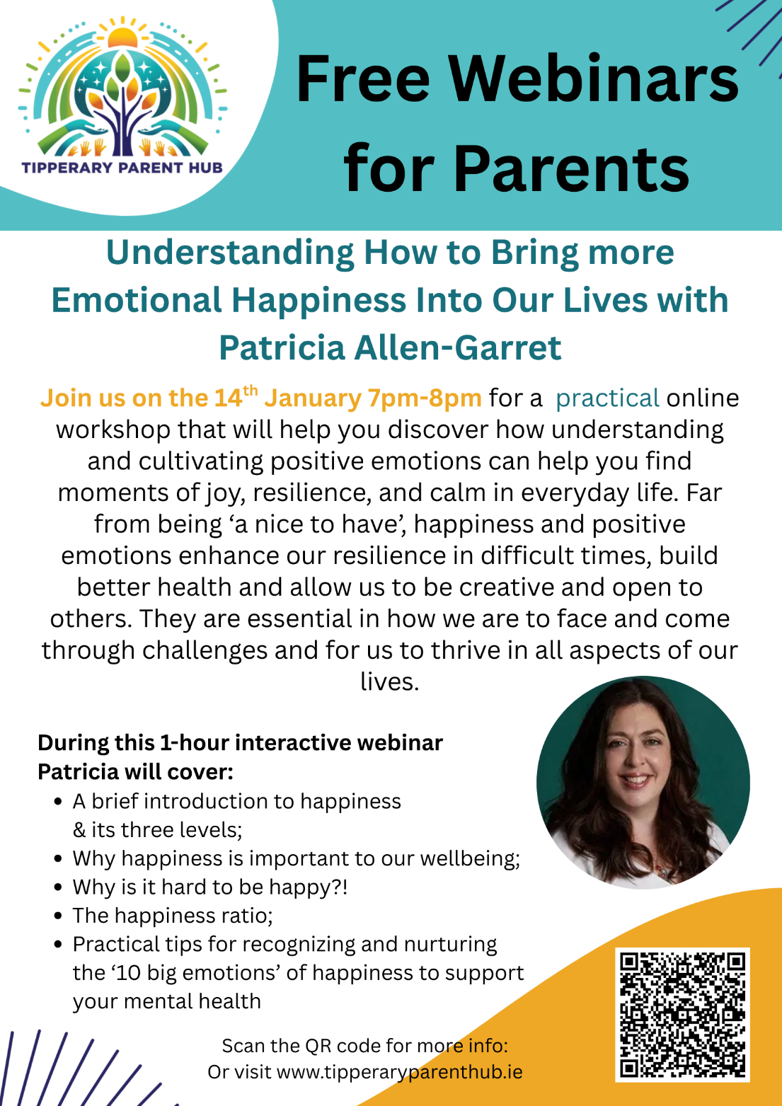

Please see poster attached as a reminder of the January Parent Hub webinar, Wednesday 14th January 7-8pm. Use QR code in poster which will direct to Parent Hub website with link to join the webinar, there is no need to register in advance, just follow link on the evening and join. This is the direct link to website event page where link for webinar will be available: Free Webinar - Understanding How to Bring more Emotional Happiness Into Our Lives with Patricia Allen-Garret - Tipperary Parent Hub

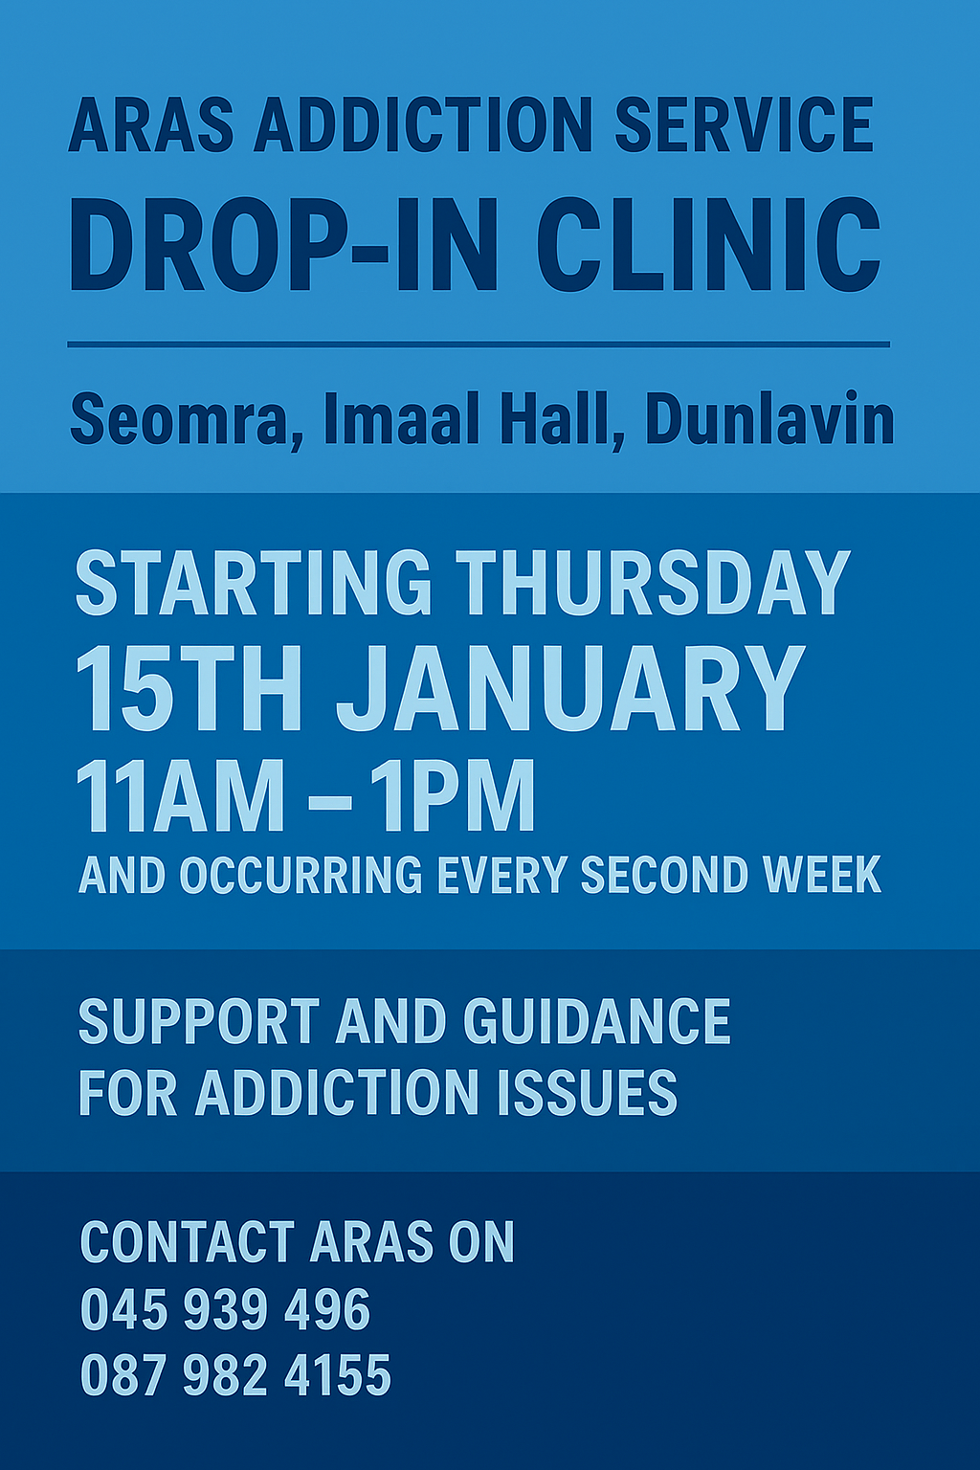

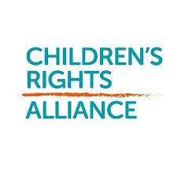
Recruitment for the Guardian ad Litem National Service
Dear Members and friends,
We would like to inform you that the Guardian ad litem National Service is now seeking to recruit Guardians ad litem (GALs) across a number of a number of locations.
The establishment of the National Service as an Executive Office of the Department of Children, Disability and Equality in November 2025, will lead to the opening of regional offices in Dublin, Cork and Galway in the coming months. This is to facilitate the provision of the National Service to children and young people, and courts, in every county in Ireland.
The Child Care (Amendment) Act 2022 provides for reform of the Guardian ad litem system, and was signed into law on 19 July 2022. Reporting to a Regional Manager for oversight of their work, recruited GALs will perform duties in line with the role and function set out in Section 35E of the Act.
The closing date for applications is Thursday 15 January 2026.
More information and details on how to apply can be found here.
Kind regards,
The Children’s Rights Alliance Team

This Bereavement Information Evening is open to all bereaved parents regardless of the age the child died, the circumstances of their death, or the time since bereavement. Our guest speaker for the evening will be Róisín Finnegan.
Bereaved parents are warmly invited to register here:
Register here for Anam Cara Online Bereavement Information Evening

If you’re thinking about New Year’s resolutions, why not consider a resolution like “attend one ARCHES course or social event and feel proud about it”? No gym memberships are required. No kale is involved. Just an openness to learn from, and share your insights and wisdom with, others.

Here’s what courses are coming up over the next 3 months:
- Understanding Anxiety: Learn practical tools to experience calm.
- Challenging Stigma, Reclaiming Identity: Explore self-worth, belonging, and identity.
- An Introduction to Trauma Informed Care: Understand compassionate approaches that support healing and growth
- Recovery in Colour 2: Use ‘art journalling’ to make meaning and look after yourself.
- Boost Your Resilience Through Strengths: Build confidence through your life values and strengths.
- Discovering Talking Therapies: Know your therapy options and how to access them.
- The Mindfulness Based Wellbeing Programme: Develop mindfulness skills for health and vitality.

Here’s our once off sessions taking place:
- Improving Sleep: Learn how to prioritise rest and restoration.
- Engaging in Self-Care: Create your personal self-care plan.

Here’s what social events are happening:
- Harmonies of Hope Choir Sessions: Sing with others for wellbeing and connection. There are only 10 available places left in 2026, please email info@archesrecovery.ie to secure one.
- Creative Café: Experience relaxed creativity in a supportive community.
- ARCHES Open Days: Meet our facilitators, learn about us, and feel welcome.

Everything is delivered in person across our locations in Clonskeagh, Bray, Sandyford, Killadreenan, and Wicklow Library—with friendly facilitators and welcoming spaces. See the attached programme and calendar for times and dates.
How to book
Booking is easy—just choose one of these options:
- Book online using our website booking system: https://www.archesrecovery.ie/our-programme/
- Or email ARCHES Admin Support on info@archesrecovery.ie or phone us at 087 342 9922 to check availability and book a place.

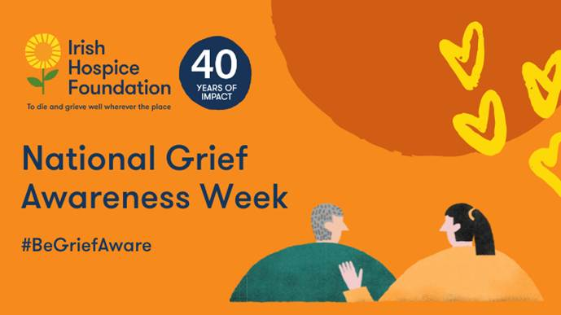

Show You Care. Be Grief Aware.

Death is such a difficult thing for any of us to face. Despite it being widespread, grief is often misunderstood. Grief is a natural response to the death of someone close. It does not follow a definite pattern and can be different for everyone. People who are bereaved can be left feeling isolated, lonely and confused. Family and friends may be unsure how best support them. Learning more about grief can help someone before and during the grieving process and can also help the people supporting them.

As Part of This Years Campaign

- We have a downloadable promotion pack and a promotional assets page for social images and suggested messaging to share on social media, in your newsletters, emails or other channels.
- We are running a social media campaign to raise awareness of grief, what can help when grieving and ways you can support someone who is grieving. We would encourage you to join the online campaign. Please like, share and repost any of our NGAW messaging so that your networks can be aware of the campaign and the information within it can be shared with them.

How You Can Participate in National Grief Awareness Week?

We want to spread awareness about this campaign and the information and events taking place within it, in the same way that you might plant seeds a garden. Use the acronym ‘The Sow’ to remember all the ways that you can participate in this year’s National Grief Awareness Week campaign.

- TELL people you know, including family, friends, colleagues, and your community about the campaign.
- HOST a stand displaying the campaign poster and bereavement information in your workplace or community hub (visit our website to order your pack)
- EMAIL your colleagues/networks with the details and a link to this webpage or print off some of our promotional assets and make them accessible to your colleagues.
- SHARE on your social media accounts using our promotional assets and using #NGAW2026 #BeGriefAware and tagging our social media accounts.
- ORGANISE a showing of the lunchtime webinar or evening webinar for your colleagues, service users or community.
- WATCH our three-minute informational video about grief and share the video link with your friends and family.

For more information about National Grief Awareness Week or to order your ‘Host a Stand’ pack, please visit our website

If you have any questions, please don't hesitate to contact us at bereavementdevelopment@hospicefoundation.ie
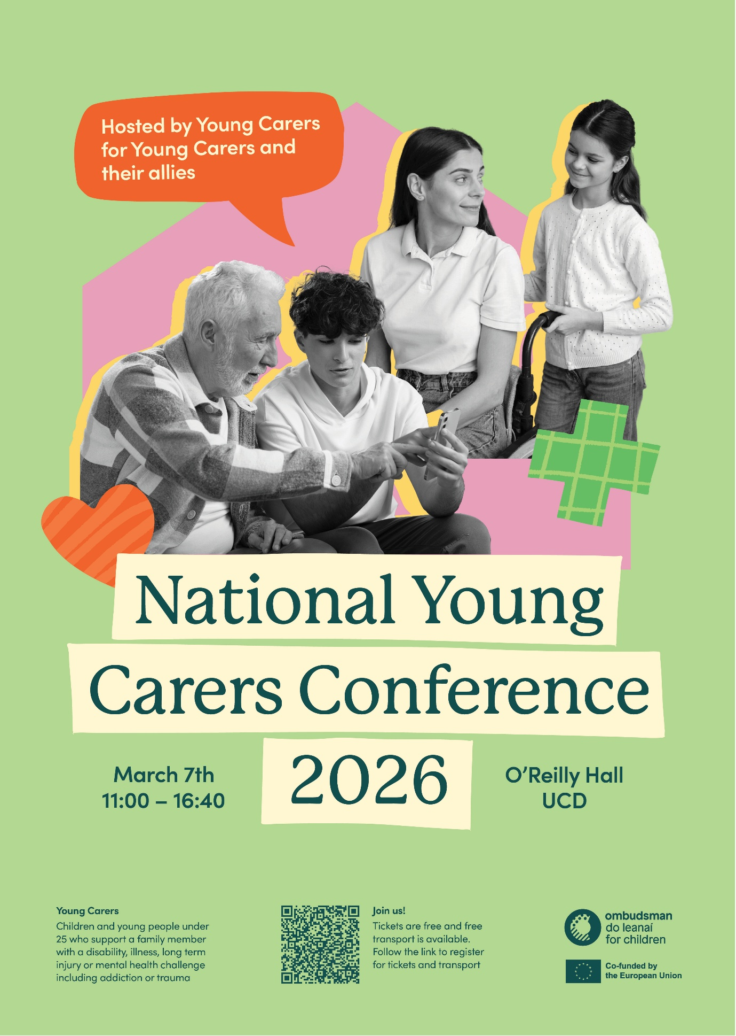

REMINDERS

Hi All,

Please share widely, an exciting employment opportunity within Wicklow Child and Family Project.

Exciting employment opportunity: Under 18 Project Worker - County Wicklow Partnership

Or on Activelink:

www.activelink.ie/node/119784

Closing date 12th January 2026 @ 12 noon

Wishing you all a Happy peaceful Christmas and New Year, from all here at Wicklow Child and Family Project

Jenny and WC&FP Team

Jenny Smith
Manager
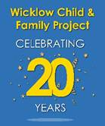

Dear Connecting for Life member,

Please see details attached on the range of FREE suicide prevention related training for Q1 & Q2 2026. Please circulate and promote amongst your network as appropriate.

Please also see information attached on the Volunteer Information Sessions by one of our CfL partners, HUGG. I would be grateful if you could promote through your network.

Thank you again for your ongoing support of Connecting for Life and the reduction of suicide and self-harm in the area.

Adam Byrne
Oifigeach Réigiúnach Um Fhéinmharú a Chosc (Meabhairshláinte) | FSS Bhaile Átha Cliath Theas agus Cill Mhantáin
Resource Officer for Suicide Prevention (Mental Health) | HSE Dublin South and Wicklow

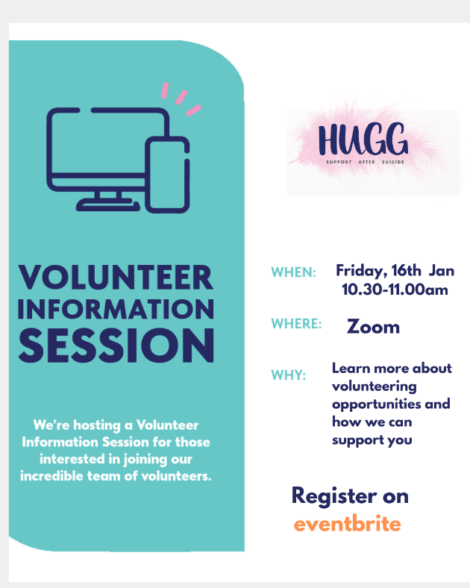

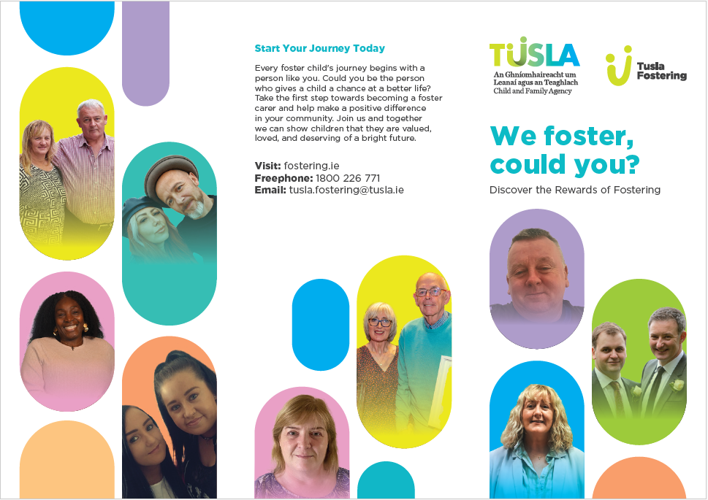

Tusla Fostering is looking for opportunities in 2026 to attend any relevant events where it might be possible for them to have an information stand to create awareness of urgent foster carers needed in Ireland and your area. They can also deliver presentations to any organisation who would be interested to hear about fostering and can invite a foster carer who can share their experience. As you might be aware we have almost 6000 children on our system in care and 90% are in fostering.

Val McGuinness
Fostering Recruitment Coordinator for DML/DNE
Tusla Child and Family Agency
Mobile:0877125139 / Email: valerie.mcguinness@tusla.ie/Valerie.mcguinness@tusla.onmicrosoft.com
Level 3, Chambers House, Belgard Square West, Tallaght, Dublin 24

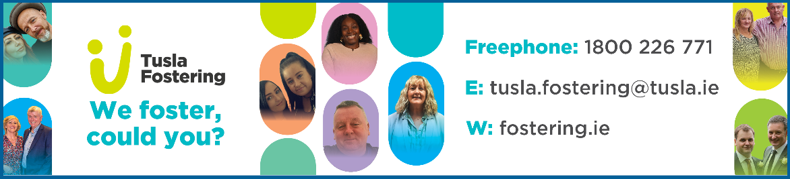

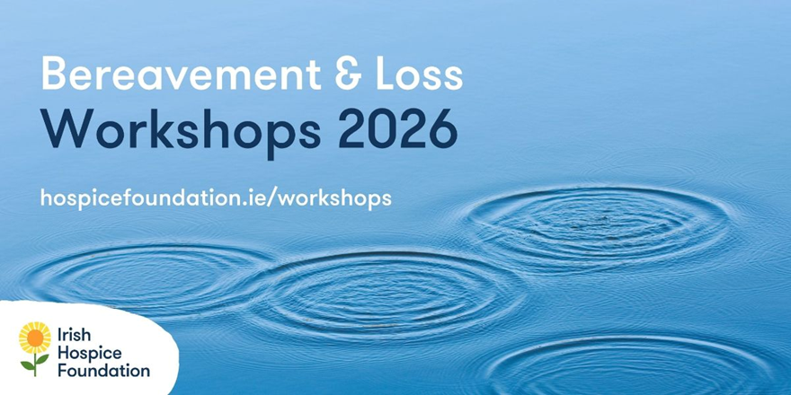

From January to June, we’ll be running 19 online workshops, covering a range of topics on bereavement and loss.

These workshops are for professionals and volunteers who may wish to learn about bereavement and loss, and for those working with people who have experienced a loss. The aim of the workshops is to equip attendees with the understanding of the grieving process, communication skills, and appropriate methods for supporting those who are bereaved.
The workshops are facilitated by practitioners who specialise in specific aspects of bereavement and loss and bring a wealth of experience and knowledge to the training.
Workshops are €100 for a full-day workshop and €70 for a half-day workshop.

See all workshop topics

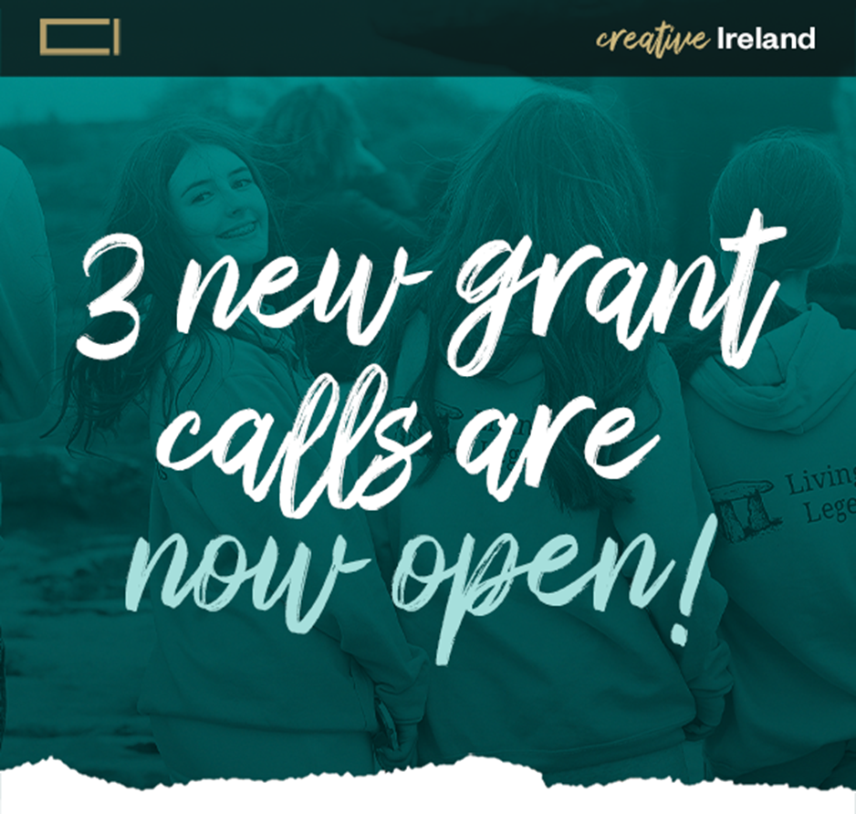

The Creative Ireland Programme is delighted to announce three new funding calls supporting creativity, connection and wellbeing across
the island of Ireland.
These new funding opportunities advance Creative Ireland’s mission to support inclusive, meaningful participation in creativity, strengthen communities, and nurture everyone’s creative potential.
Closing Date: February 27, 2026 — 1pm
An in-person Grant information session will take place, and all are welcome to attend. Booking is required:
January 22, 2026 | Raddison Blue Hotel, Golden Lane Dublin (Booking link)
An online information session for the Creative Youth grant call will take place on December 15 Register Here

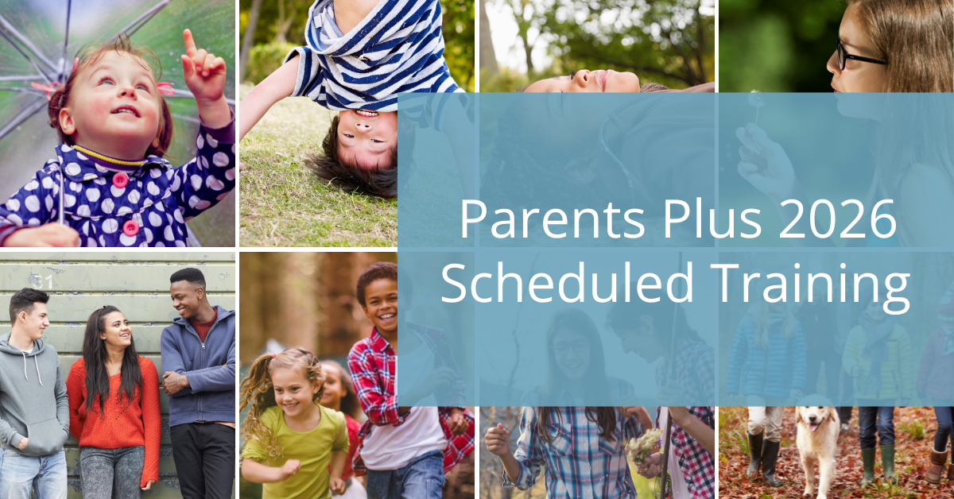

Parents Plus is now taking bookings for facilitator training in each of our eight evidence-based parenting and mental health programmes in early 2026. Take a look at the schedule.

