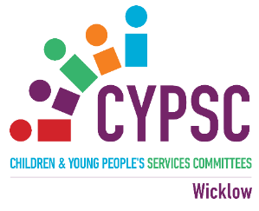
Welcome to the Christmas Wicklow CYPSC News Update:
22nd December 2025
Page 2 & 3: That’s a wrap…Thank You!
Page 4: Sleep Project Launch
Page 5: Wicklow Local Community Safety Partnership Launch
Page 6: Employment Opportunity – U18 Project Worker
Page 7: HSE - National Needs Assessment for the Prevention of Drugs and Alcohol in Ireland (deadline 5th January 2026)
Page 8: Free Suicide Awareness Training in 2026 and HUGG Volunteer Information Sessions and Request
Page 9: Mental Health Supports open 24/7 over Christmas and New Year
REMINDERS
Page 10: Tusla Fostering looking for events in 2026
Page 11: Irish Hospice Foundation - Bereavement and Loss Workshops 2026
Page 12: Creative Ireland Call for Applications 2026 (Check out the dates for Information Sessions – 1st one 15th December – booking required)
Page 13: Tusla Child and Youth Participation Training 2026 (open to Tusla funded services)
Page 14: Parents Plus Facilitator Training 2026
Page 15: Katie Taylor Bursary Open for Applications (Closing 5th Jan 2026)

Fionnuala Curry
Coordinator, Co. Wicklow CYPSC
Fionnuala.curry@tusla.ie or call 087 6043511

That’s a wrap…

Across our lines and shared intent,
Your steady hands and time were lent.
In 2025, through trust and care,
You bridged the gaps and met me there.
With thanks for partnership, wisdom, and grace-
This work was stronger because of you.

So many exciting developments during 2025 and looking forward to more in 2026. Thank you all for your help and support in 2025 whether you are on the main committee, a subgroup or a working group – thank you!!
Wishing everyone a happy and peaceful Christmas and New Year and looking forward to working with everyone in 2026.

Here are some of the highlights of 2025!
CYPSC/IPSS Funding totalling almost €92,000 has been utilised in the county to provide supports for children, young people and families living in the International Protection Centres in the county.
CYPSC/Healthy Ireland Funding totalling €59,000 have been used to support the establishment of the Health & Wellbeing Hub in Bray, the Youth Mental Health campaign ‘Gr 8 2 B Yng’ and the provision of physical activity opportunities for young people with additional needs.
Decider Skills Training took place in January 2025 for up to 50 participants across DLR and Wicklow and a Community of Practice took place in October 2025. Wicklow CYPSC will host the next CoP in early 2026.
Countywide LGBT event took place in February 2025.
Three free Parent Talks took place to great success in both Q1/2 and Q3/4 2025. Six events across the year attended by up to 1,000 parents and more receiving the link to the talks, the slides and list of resources created. We look forward to working with Dr. Tara Kelly on rolling out these talks again in 2026 and we are grateful to her for lending her expertise to the parents across Wicklow and DLR.
The Family: Adult & Child Enhanced Services, FACES, Child Poverty Pilot recruited the Research Network Specialist in February 2025 and employed a Human Learning Specialist to support us in the development of our Learning Cycles and building our understanding of HLS. Family facing consultations have commenced and we look forward to Year 2 and the identification and delivery of interventions to target families using a HLS approach.
The maternal mental health campaign ‘Minding Me’ took place in May 2025.
The Irish Childhood Bereavement Network provided ‘Understanding Children’s Grief’ training for professionals in Wicklow in June 2025 for up to 25 participants.
Parentingsupport.ie was relaunched in October 2025 which was the culmination of a significant piece of work by Kildare CYPSC and Wicklow CYPSC and the new site hosts In Sync Youth and Family.
Transitions tool ‘Step by Step’ developed and distributed in October 2025.
School Directory reviewed and distributed to all primary schools in October 2025.
The Planet Youth Ireland Conference took place in April 2025. The Planet Youth County Report launched in October 2025 and dissemination of the findings has been ongoing throughout 2025 – looking forward to the second survey in November 2026!
Children and Young People’s Plan 2025-27 was launched in October 2025.
Elephant in the Room Launch also took place in October 2025.
Sleep Project Resources Launch December 2025.
Wicklow CYPSC representation on the newly launched Wicklow Local Community Safety Partnership December 2025.
Wicklow CYPSC continues representation on several key structures across the county including the Wicklow Sports & Recreation Partnership, the Local Community Development Committee, the Community Integration Forum, the Social Inclusion Network Group SING and Disability Inclusion Steering Committee DISC. In addition, Wicklow CYPSC also represents the CYPSC Coordinator’s Network on the Irish Childhood Bereavement Network.

None of this would be possible without your support. I am truly grateful to you all and look forward to working with you in 2026 to work more magic!!

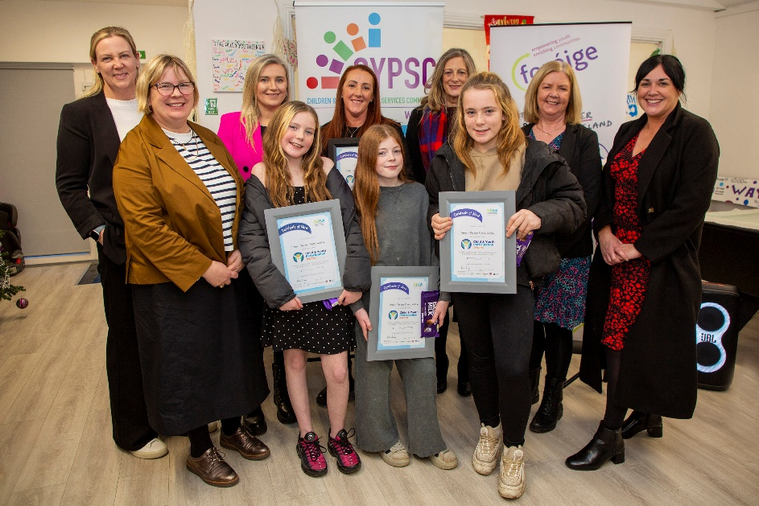
Sleep Project Launch
On Thursday, 4th December 2025, Wicklow Children and Young People Services Committee [Wicklow CYPSC] launched the Sleep Project resources in the Foroige, The Way Project in Rathnew, Co. Wicklow.
This project is a multi-agency response to concerns about the negative impact of poor sleep habits to the overall wellbeing of children and young people. Sleep plays a vital role in positive mental health and influences moods, memory and how we manage information. Research shows a link between poor sleep and health problems. The Sleep Project supported by Healthy Ireland funding has developed two short videos, ‘How to get the best sleep?’ and the ‘Benefits of Sleep’, as well as a leaflet for parents.
Foroige - The Way Project and Kildare and Wicklow Education and Training Board (ETB) staff worked with young people from the project to co-produce the resources. The children provided the drawings and their voices to animate the videos. The project received the Tusla Child and Youth Participation Award for its work and the award was presented on the day by Berni Smyth new Area Manager for Tusla Wicklow.
How to get the best sleep https://youtu.be/iSF64ULWOEA
Benefits of Sleep https://youtu.be/bHN4zpt2pKU
Importance of Sleep – Parents’ Tips https://www.cypsc.ie/_fileupload/Documents/Resources/Wicklow/importance-of-sleep-parent-tips.pdf
For more information contact Fionnuala Curry 087 6043511
For more information on Wicklow CYPSC visit https://www.cypsc.ie/your-county-cypsc/wicklow.254.html

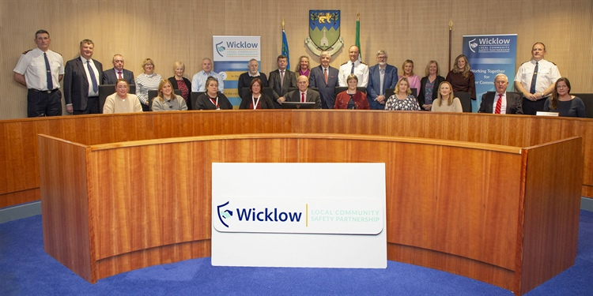

Wicklow Local Community Safety Partnership Officially Launched

The Wicklow Local Community Safety Partnership (LCSP) was formally launched last Thursday, 4th December, with its inaugural meeting held in the Wicklow County Council Chamber.
At the meeting Cllr. Tom Fortune was elected as Chairperson and Selena Mckenzie was elected as Vice-Chairperson. In addition, a working subgroup was established to commence work on developing a three-year Local Community Safety Plan for County Wicklow, which will set out tailored actions to address the specific needs of communities across the county.
A total of 36 Safety Partnerships in every local authority area across the country are being established under the Policing, Security and Community Safety Act 2024. The Partnerships will build on the work of Joint Policing Committees, expanding them to include broader community, voluntary, and statutory involvement. The aim is to strengthen collaboration across agencies and local groups, all working together to enhance safety and wellbeing throughout the county.

Hi All,

Please share widely, an exciting employment opportunity within Wicklow Child and Family Project.

Exciting employment opportunity: Under 18 Project Worker - County Wicklow Partnership

Or on Activelink:

www.activelink.ie/node/119784

Closing date 12th January 2026 @ 12 noon

Wishing you all a Happy peaceful Christmas and New Year, from all here at Wicklow Child and Family Project

Jenny and WC&FP Team

Jenny Smith
Manager
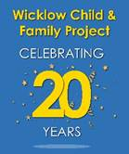
The Health Service Executive (HSE) is undertaking a National Needs Assessment for the Prevention of Drugs and Alcohol in Ireland, coordinated by the National Health Improvement Team (Public Health). As part of this work, we are inviting professionals and organisations from across sectors to complete a short online survey.

The survey seeks to capture the perspectives of those working with children, families, young people, communities, and underserved groups, including those whose work focuses on health, wellbeing, education, community development, and social support.

Your participation is important in helping us to better understand community needs, identify challenges and concerns relating to drug and alcohol use, and recognise opportunities to strengthen prevention across the life course. The findings from this survey will feed into a wider programme of work contributing to the national needs assessment, which will inform future HSE planning, policy development, and prevention programmes. A report outlining the findings of this work will be published in 2026.

The survey is informed by findings to date from focus groups and a workshop. It takes approximately 10–12 minutes to complete (please note that responses will not be saved unless the survey is submitted in one sitting).

We would be very grateful if you could complete the survey and, where appropriate, share the survey link within your networks to support broad and diverse participation. If you would like us to follow up with you regarding the findings or the final report, or if you have any queries in relation to this work, please contact us by email on: NationalHealthImprovement@hse.ie.

All responses will be treated anonymously and reported in aggregated form by our research partner, Ipsos B&A, and will be used solely for research purposes to inform future initiatives. We greatly appreciate your contribution to this important work. The deadline for completing the survey is 5th January 2026

Please follow the link below to complete the survey:

Dear Connecting for Life member,

Please see details attached on the range of FREE suicide prevention related training for Q1 & Q2 2026. Please circulate and promote amongst your network as appropriate.

Please also see information attached on the Volunteer Information Sessions by one of our CfL partners, HUGG. I would be grateful if you could promote through your network.

Thank you again for your ongoing support of Connecting for Life and the reduction of suicide and self-harm in the area.

Adam Byrne
Oifigeach Réigiúnach Um Fhéinmharú a Chosc (Meabhairshláinte) | FSS Bhaile Átha Cliath Theas agus Cill Mhantáin
Resource Officer for Suicide Prevention (Mental Health) | HSE Dublin South and Wicklow

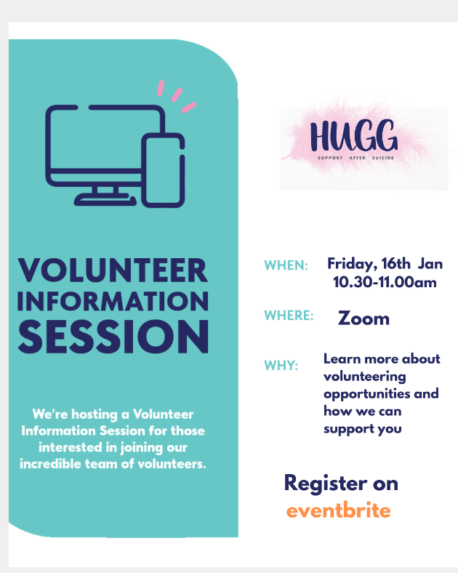

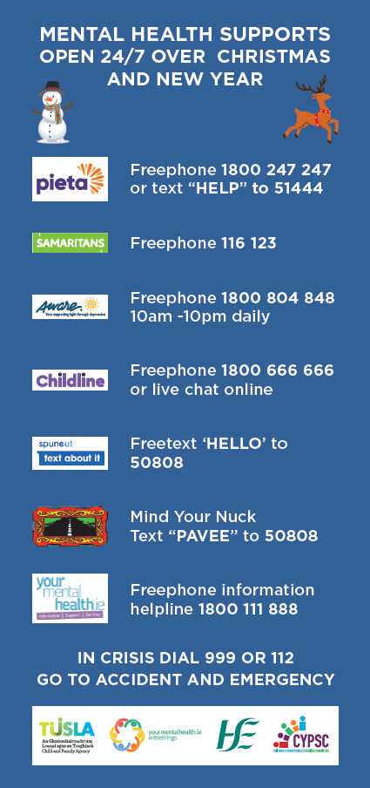

REMINDERS

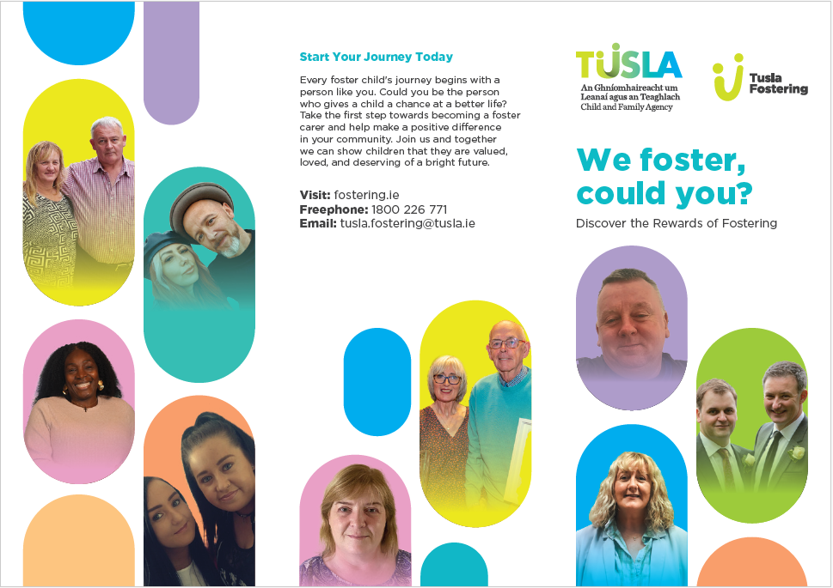

Tusla Fostering is looking for opportunities in 2026 to attend any relevant events where it might be possible for them to have an information stand to create awareness of urgent foster carers needed in Ireland and your area. They can also deliver presentations to any organisation who would be interested to hear about fostering and can invite a foster carer who can share their experience. As you might be aware we have almost 6000 children on our system in care and 90% are in fostering.

Val McGuinness
Fostering Recruitment Coordinator for DML/DNE
Tusla Child and Family Agency
Mobile:0877125139 / Email: valerie.mcguinness@tusla.ie/Valerie.mcguinness@tusla.onmicrosoft.com
Level 3, Chambers House, Belgard Square West, Tallaght, Dublin 24

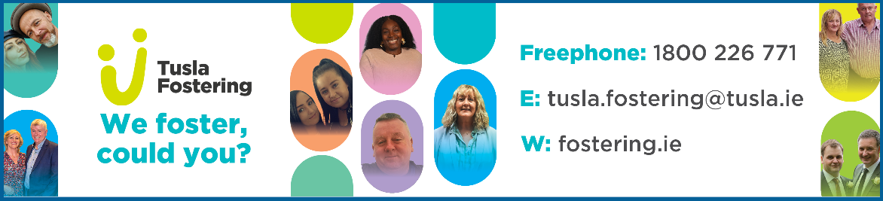

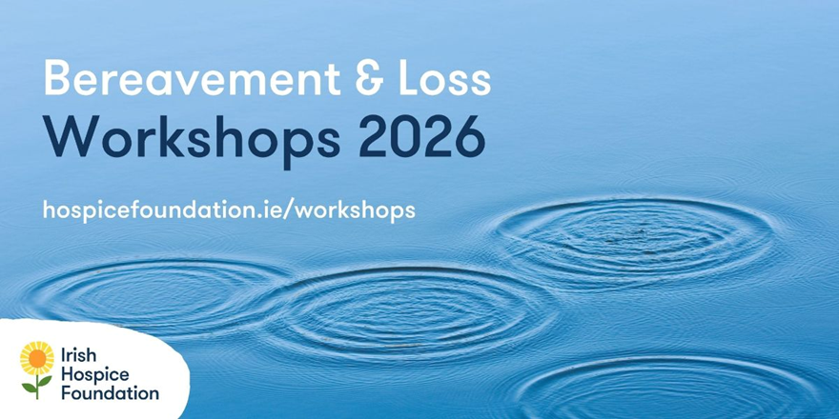

From January to June, we’ll be running 19 online workshops, covering a range of topics on bereavement and loss.

These workshops are for professionals and volunteers who may wish to learn about bereavement and loss, and for those working with people who have experienced a loss. The aim of the workshops is to equip attendees with the understanding of the grieving process, communication skills, and appropriate methods for supporting those who are bereaved.
The workshops are facilitated by practitioners who specialise in specific aspects of bereavement and loss and bring a wealth of experience and knowledge to the training.
Workshops are €100 for a full-day workshop and €70 for a half-day workshop.

See all workshop topics

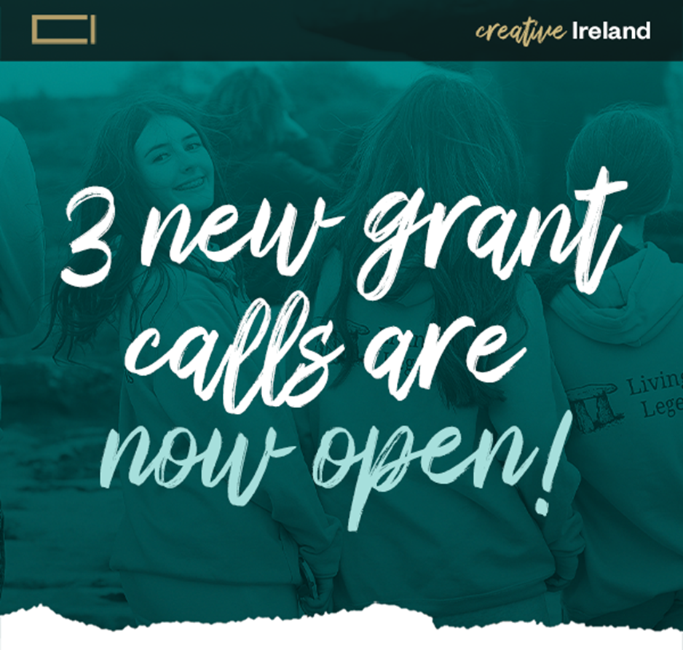

The Creative Ireland Programme is delighted to announce three new funding calls supporting creativity, connection and wellbeing across
the island of Ireland.
These new funding opportunities advance Creative Ireland’s mission to support inclusive, meaningful participation in creativity, strengthen communities, and nurture everyone’s creative potential.
Closing Date: February 27, 2026 — 1pm
An in-person Grant information session will take place, and all are welcome to attend. Booking is required:
January 22, 2026 | Raddison Blue Hotel, Golden Lane Dublin (Booking link)
An online information session for the Creative Youth grant call will take place on December 15 Register Here

Tusla Child & Youth Participation Training

We are delighted to offer our dates for Tusla Child and Youth Participation Training Online. There are several modules of learning to be completed in successive order as part of this blended learning programme. (Available to Tusla funded services)

The following modules must be completed to receive certification:
1
1. eLearning Module: 'Child and Youth Participation - An Introduction'. (40 minutes)

2. Virtual Classroom 1: 'Child and Youth Participation: Applying the Lundy Model of Participation'. (3.5 hours)

3. Self-directed Learning Module: 'Implementing Participatory Practice'. (3 hours approximately)

4. Virtual Classroom 2: 'Child and Youth Participation: Sharing the Learning'. (2 hours)

When you book onto Virtual Classroom 1 you are automatically assigned Virtual Classroom 2 date which is approximately 6 weeks later.

Dublin Mid Leinster
Applying the Lundy Model  Virtual Classroom 1 | Sharing the Learning  Virtual Classroom 2
19th Jan 2026 09:15 – 13:00 | 23rd Feb 2026 09:30 – 12:30
26th Feb 2026 09:15 – 13:00 | 26th March 2026 09:30-12:30
3rd March 2026 09:15 – 13:00 | 13th April 09:30-12:30

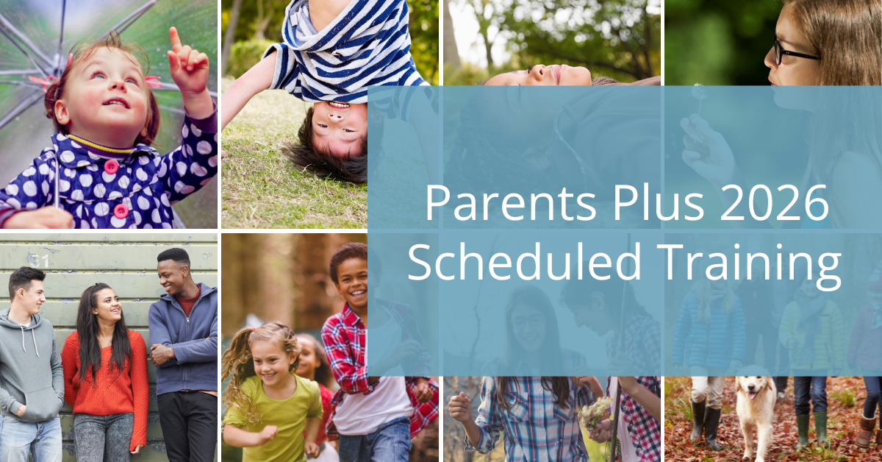

Parents Plus is now taking bookings for facilitator training in each of our eight evidence-based parenting and mental health programmes in early 2026. Take a look at the schedule.



Wicklow County Council and Wicklow Sports & Recreation Partnership have opened the application process for the Third level Katie Taylor bursary award for 2025/26.
The Katie Taylor Bursary, funded by Wicklow County Council, is a third level award to support students who excel at sport to complete their college education.
The award of €1,500 per year of college, is open to students who live in Wicklow that are now, currently enrolled, in their first year of third level education, studying Level 7 or 8.
Students are not required to study a sports related course, but will need to demonstrate their involvement, commitment, and achievements in sport.
Closing date for applications is 12 noon Monday 5th January 2026.

Applications are open for our Katie Taylor College Bursary.

